- There was a small upside surprise for UK CPI inflation in June as services inflation again overshot expectations. Part of this was due to movements in volatile categories, which we expect to unwind in July, so we don't see today's data as reason to make major changes to our inflation forecast.
- We continue to think that headline inflation is close to its trough. Core inflation should remain sticky, owing to the passthrough of still-high pay growth, meanwhile the drag from fall energy prices will start to fade from July, pushing up headline inflation slightly as we progress through H2 2024.
CPI inflation held steady at 2% in June. We had expected a slightly lower reading, largely due to the downward pressure on the food and core categories from base effects and the indirect effects of lower energy prices. But core inflation, and in particular services inflation, proved sticky and were unchanged at 3.5% and 5.7% respectively. Moreover, there was little movement in the other main inflation categories. RPI inflation edged down to 2.9% in June, from 3% in May, while RPIX inflation remained at 1.9%.
That June's services inflation reading was slightly higher than expected, was partly due to a 3.3% m/m rise in accommodation services prices, which we expect to unwind in July's data. Therefore, we see little reason to make wholesale changes to our CPI inflation, though the higher starting point from today's data has nudged our 2024 CPI inflation forecast up to 2.6% in 2024, 0.1ppt higher than in last month's forecast.
Apart from a temporary dip in September, we think headline CPI inflation is now at its trough. Services inflation is likely to remain sticky due to the passthrough of still-high pay growth and the impact of April's once-a-year price hikes for many index-linked contracts and regulated prices, which baked in high inflation to these categories over the next year. Month-to-month movements in headline inflation will be heavily influenced by the energy category, which will start to weigh less heavily from July.
Chart 1: Stickier services inflation in June has raised our 2024 inflation forecast to 2.6%
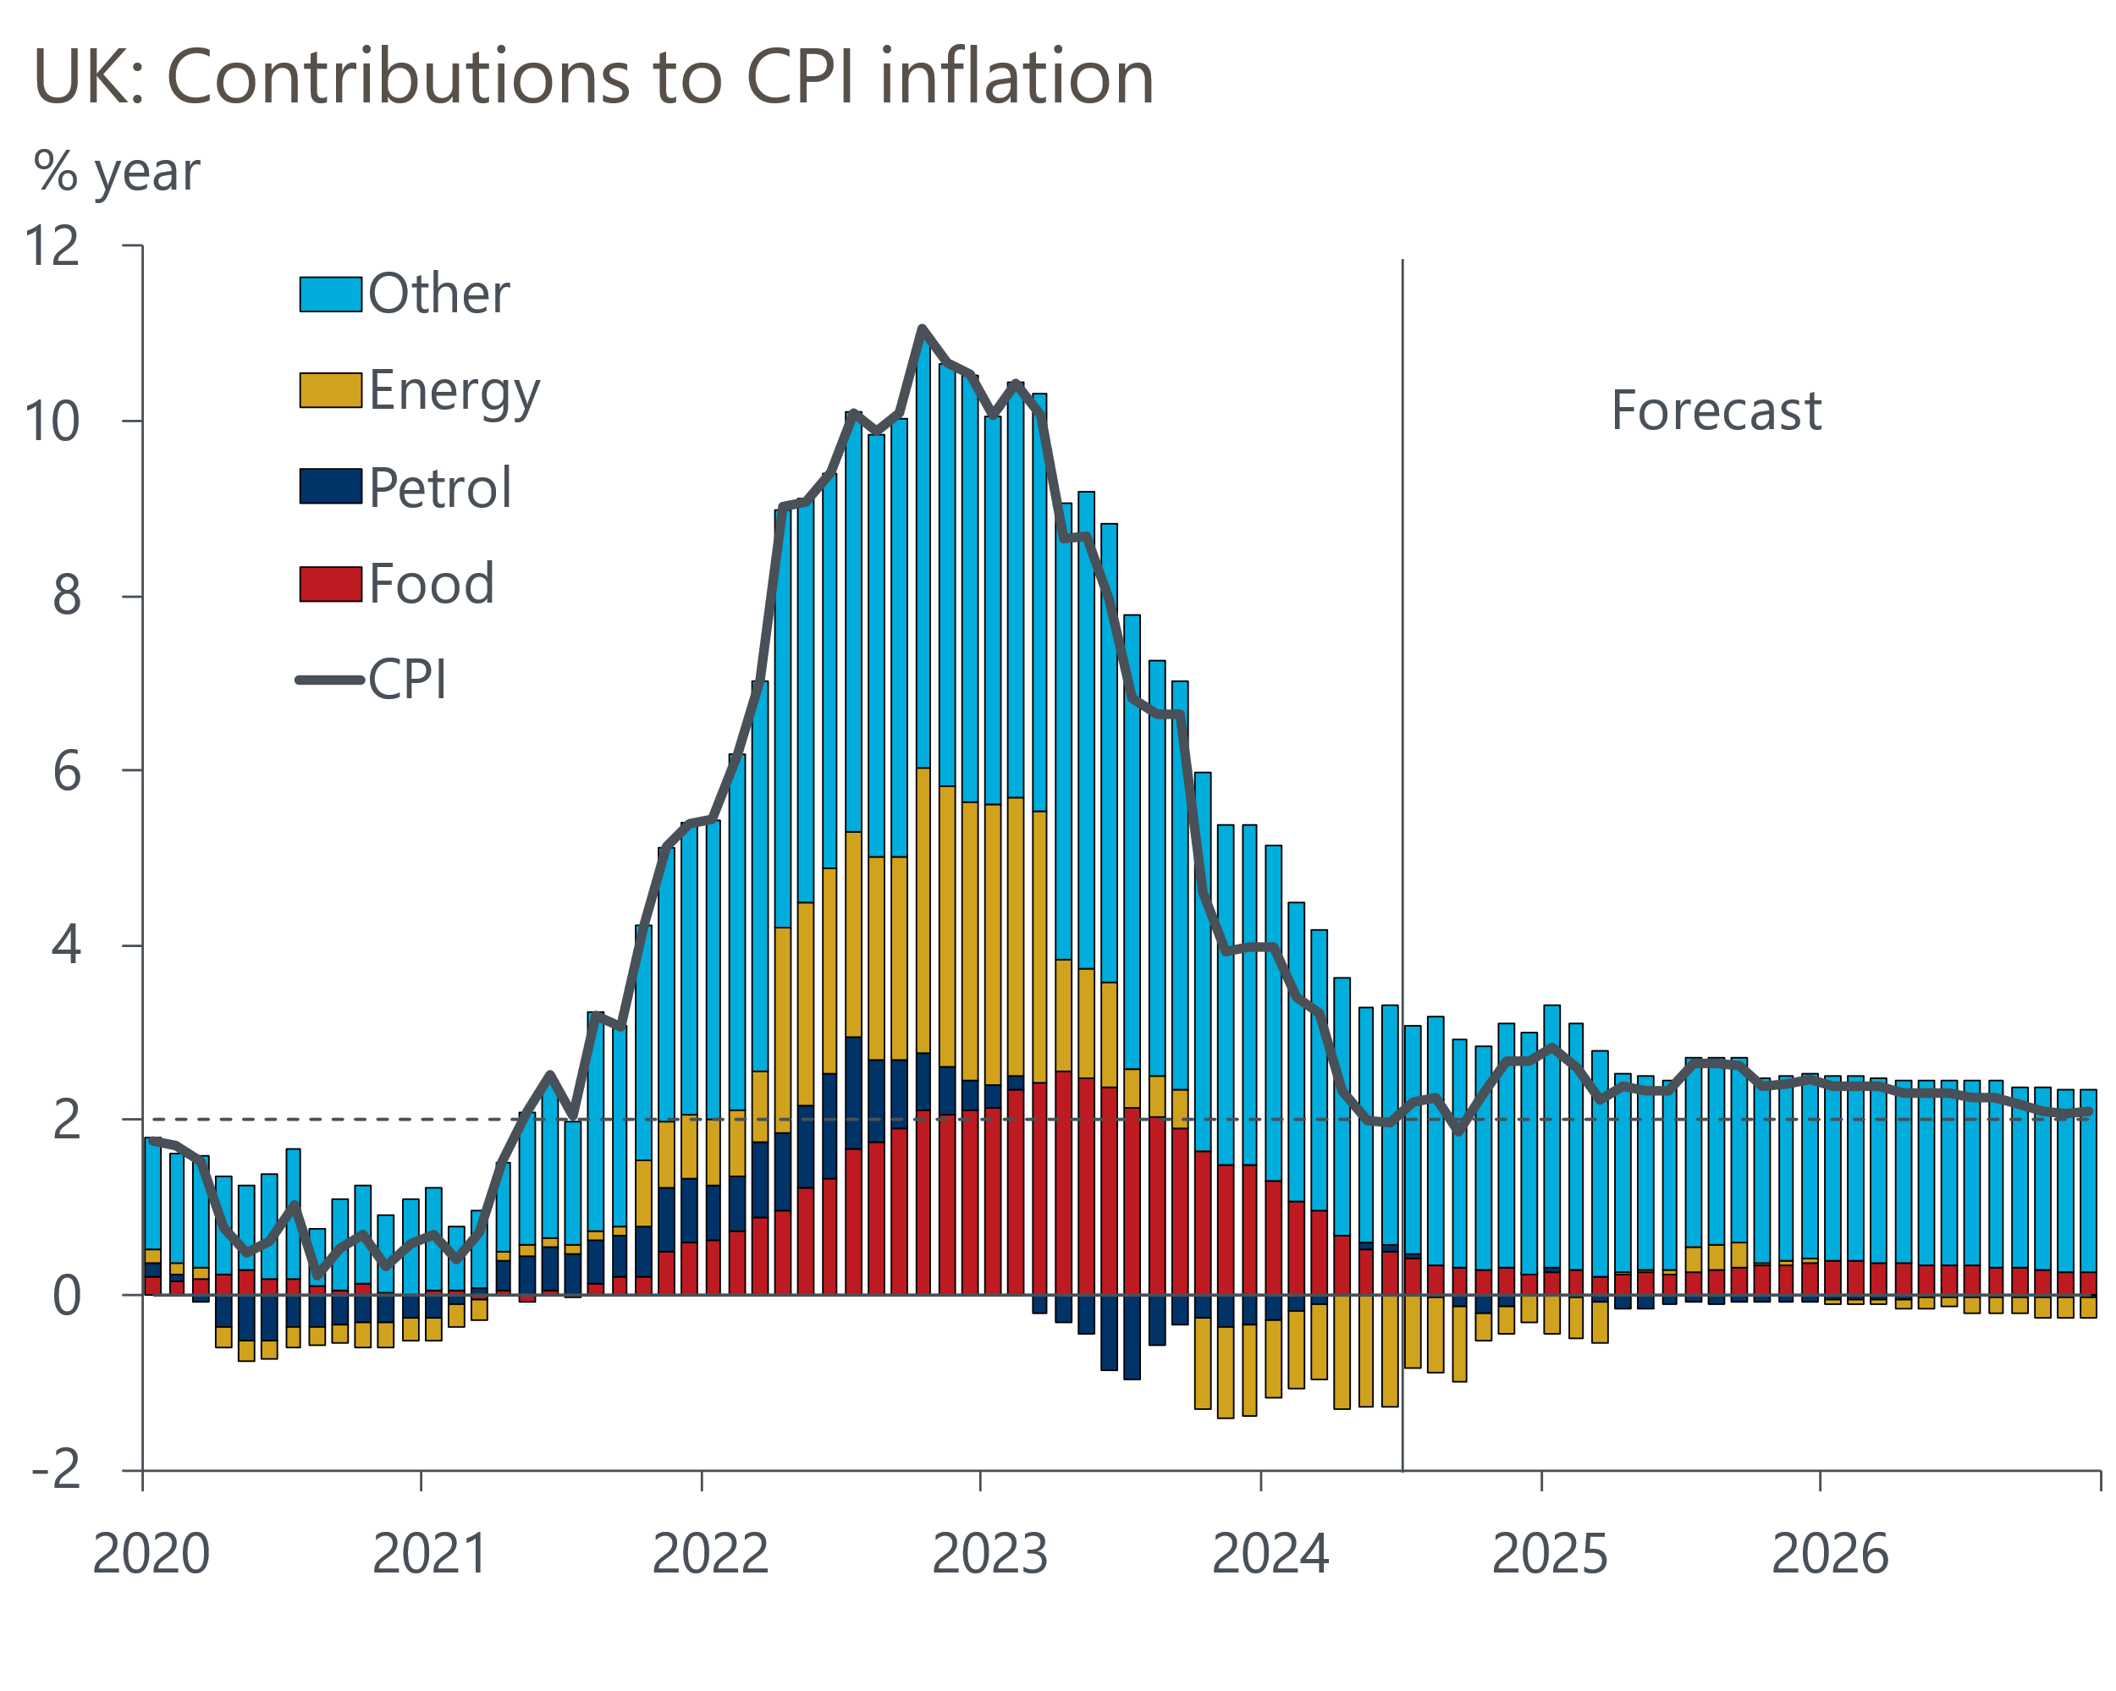
Source: Oxford Economics, Haver Analytics

